Advancing on an error

If one or more runners advance beyond the bases they had legally reached thanks to an error committed against the batter or another runner, their advance is recorded in the box corresponding to the base reached by noting in parentheses the batting order number of the batter or runner against whom the error was committed.
Example 31: With a runner on first base the batter hits towards the third baseman, who muffs an assist to first base, enabling the batter to reach second base and the runner to reach third. The runner’s arrival on second base is recorded with the number two, without parentheses, since he reached it on the play (the runner would have reached the base even if the throw by the third baseman had been perfect), and the runner’s arrival on third base is noted with the number two in parentheses, as the base was reached thanks to the error committed against the batter who was second in the batting order.
WBSC |  | Traduction dans l’outil de scorage |  | Outil
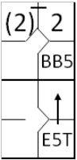 |  | /* Le premier batteur gagne la première base sur un 'base on ball' */  action { batter -> BB }  /* Le deuxième batteur frappe une balle vers le défenseur de troisième base. Le défenseur récupère la balle mais commet une erreur en la relayant */  action { batter -> E5T+ , runner1 -> + (2) } |  | 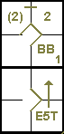

Example 32: With a runner on first base and another on third, the pitcher tries to pick off the runner on first base, but muffs the throw.
Thanks to this error, the runner on third scores a run and the runner on first base advances to second.
The advance by the runner on third base is scored with the number five in parentheses, since he took advantage of the error against the runner who was fifth in the batting order; in this case the arrival of the hindmost runner on second base is considered to have been due to an extra base error. For this runner we mention the number of the player at bat at the time of the error in the upper corner of the base square.
WBSC |  | Traduction dans l’outil de scorage |  | Outil
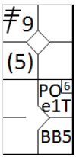 |  | /* Le premier batteur frappe un triple dans le champ droit */  action { batter -> 3B9 }  /* Le deuxième batteur arrive sur base sur un 'Base on ball' */  action { batter -> BB }  /* Le lanceur tente un PickOff sur le coureur en 1, mais manque sont lancé. Le coureur en profite pour gagner la deuxième et le coureur en marque */  action { runner1 -> POe1T , runner3 -> (2) } |  | 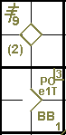
ATTENTION: If a decisive error is committed with two men out, no advances are considered to have been on hits, and all numbers are in parentheses, since if the play had been correct there would have been three putouts and no one would have been able to advance. If any fielder commits a catching error, any advances are recorded in parentheses, provided that the scorer does not consider that the runner could have advanced if the fly ball had been caught correctly.
Example 33: With runners on first and second and less than two outs, the batter hits a ground ball to the third baseman, who muffs the catch, enabling all runners to reach base safely. In this case the advances are not recorded with parentheses because, despite the error, it is assumed that the third baseman would not have been able to play for anyone other
than the batter-runner.
The runners would have reached base safely even with a correct play.
WBSC |  | Traduction dans l’outil de scorage |  | Outil
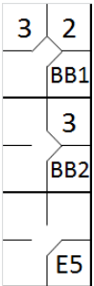 |  | /* Le premier batteur arrive sur base sur un 'Base on ball' */  action { batter -> BB }  /* Le batteur suivant arrive sur base sur un 'Base on ball' */  action { batter -> BB , runner1 -> + }  /* Le batteur suivant frappe une balle vers le défenseur de la troisième base qui commet une erreur en récupérant la balle. Les autre coureur avance sur la frappe sans tenir compte de l'erreur */  action { batter -> E5 , runner1 -> +, runner2 -> +} |  | 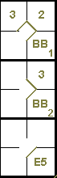
But ….
Example 34: If it is judged that the third baseman could more easily have played for the runner on second base, the action is recorded in this example, but even here there are no parentheses for the runner on third base, and the batterrunner is recorded as having reached first on fielder’s choice.
WBSC |  | Traduction dans l’outil de scorage |  | Outil
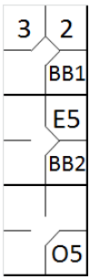 |  | /* Le premier batteur arrive sur base sur un 'Base on ball' */  action { batter -> BB }  /* Le batteur suivant arrive sur base sur un 'Base on ball' */  action { batter -> BB , runner1 -> + }  /* Le batteur suivant frappe une balle vers le défenseur de la troisième base, qui commet une erreur */  action { batter -> O5, runner1 -> E5 , runner2 -> + } |  | 